Shabbos Stories for
Parshas noach 5781
Volume 12, Issue 7 6 Cheshvan/October 24, 2020
Printed L’illuy nishmas Nechama bas R’ Noach, a”h

For a free subscription, please forward your request to keren18@juno.com
Past stories can be found on the website ShabbosStories.com

Story #1192
A Sudden Specialist
From the desk of Yerachmiel Tilles
editor@ascentofsafed.com

A certain Dr. Goldstein from Queens, an ear, nose, and throat specialist, was once visited by a couple with their daughter who was stricken with classic deafness, for which there is no known cure.
The Doctor would have dismissed them without any medical attention, but they insisted that the Ribnitzer Rebbe had sent them specifically to him for a treatment and a cure. So to appease their persistence, he prescribed a regimen of vitamins and sent them on their way.
Within a short period of time the parents received a surprising phone call from one of the teachers at the special-school for the deaf that the girl had been attending. It seems she started to exhibit signs of being able to hear. When it was verified that she could in fact hear, everyone was amazed, and Dr. Goldstein was crowned with the credit for his healing prowess.

Word Spread that Dr. Goldstein Could Cure Deafness
Word spread that Dr. Goldstein could, indeed cure deafness. He was then faced with a steep legal challenge. Since he had honestly deflected all credit he was charged with withholding treatment, which is a crime! He had to prove in a court of law that he had offered the girl no more than a placebo.
Ultimately the real cause of the cure, by default was legally credited to the miraculous powers of the Ribnitzer Rebbe, and so it was duly recorded.
Years later Dr. Goldstein received a call from the gabbai-attendant of the Ribnitzer Rebbe requesting a home visit for the Rebbe, to assist him with a problem that he was having with his hearing. After administering whatever needed to be done, the Dr. asked the Ribnitzer the obvious question.
“Why didn’t the Rebbe, who was able to make miracles happen, heal himself from his own ear ailment?”
The Rebbe quoted the Talmud (Brochos 5b) where it says, “A prisoner cannot remove himself from prison!”

The Story of R. Yochanan
There it tells about R. Yochanan who had relieved others of their pain and yet required the help of someone else to alleviate his. What we do for others, often we cannot even do for ourselves.
* Author L. Lam: Sometimes a doctor needs a doctor, a lawyer may need a lawyer, and a psychiatrist needs a psychiatrist.
** Compiler Y. Tilles: not even a Rebbe, not even a miracle-working tzadik!
~~~~~~~~~~~~
Source: Extracted and adapted by Yerachmiel Tilles from a post on Torah.org (August 26, 2010) by Rabbi Label Lam.
Biographical note: Rabbi Chaim Zanvil Abramowitz [of blessed memory: 5654* 24 Tishrei 5756 (1893* - Oct. 1995), the Ribnitzer Rebbe, was a main disciple of Rabbi Avrohom Matisyohu of Shtefanesht, grandson of the "holy Rhyzhiner" (along with Rabbi Eliezer-Zusia Portugal, founder of the Skulener dynasty
The Ribnitzer was acknowledged by all Jews across the spectrum as a renowned performer of miracles. He lived in the USSR under Stalin's rule, yet lived a fully Jewish religious life. He served as mohel and shochet, holy tasks he carried out with tremendous self-sacrifice and risk to life (frequently accompanied by the famed Chabad chasid, Rabbi Mendel Futerfas (see story #515 on this email list).
Giving Blessings to KGB Wives and Children
The Russian gentiles feared and revered him. The KGB brought their wives and children for blessings (!) and experienced miracles. It is known that from the 1930s until the end of his life he fasted on all days when it is permitted to do so under Jewish law. After emigrating from Russia in 1973, he lived in the Mattersdorf section of Jerusalem for a few years before moving to the United States, where he lived for a while in Miami, Los Angeles and Brooklyn before eventually settling in Monsey, New York. He is buried there in the Vizhnitzer Cemetery, where throngs of people flock there constantly. He was married twice but had no children.
* According to R. Mordechai (Ben David) Werdiger, who was a close follower and occasional attendant during the Rebbe’s years in Brooklyn, he was 102 years old when he passed away.
Connection : Monday, the 24th of Tishrei (the day after Simchat Torah outside of Israel), is the 35th yahrzeit of the Ribnitzer Rebbe.

Reprinted from the Parshas Bereishis 5781 email of KabbalaOnline.org, a project of Ascent of Safed.

Five Judaism Lessons
My Cat Taught Me
By Karen Kaplan

If you surveyed my friends and family, asking them the first thing that pops into their mind when they hear my name, I’d wager the almost universal answer would be, “Karen? She loves her cat.” Yup, I’m an older lady who lives alone with her cat and spends way too much time doting on the furry, little creature. Of course, Too-Too (the cat), would disagree, arguing that any time not spent doting on him is time wasted. Unless it’s spent feeding him. Humans sometimes think the world revolves around them, but cats know it does.
Numerous cats have lived with me for at least 40 years. I go through the motions of demonstrating the house rules to them. Stay off the counters. Don’t sleep on my pillow. Don’t sample my dinner when I’m not looking. I fool myself that it’s me who’s in charge. Meanwhile, they watch attentively, raising my hopes, then yawn and stretch, saunter away, and proceed to do exactly as they please. Over the years, they’ve taught me much more than I’ve ever taught them, including life lessons about Judaism, and I’d like to share some of those lessons here.

1. Speech Is What Separates Us From the Animal Kingdom
Too-Too purrs when I pet him and meows when he’s bored or hungry. He’s never hissed at me, so I know I’ve never made him angry. When he’s really happy with me, he’ll roll on his back and let me scratch his tummy. And he can wrap me around his little cat finger with an adorable pose.

Too-Too the cat.

But he will never communicate, learn, and imagine like I can, because he doesn’t have the gift of speech that G-d gave only to humans. He can make me laugh when he stalks and pounces on a stray sock, he can entertain me when he jousts with a stray paper clip, but he can’t tell a joke. He can evoke memories of my previous cats, but he can’t share a memory of his own. He can look longingly at the first robin of springtime outside my window, but he can’t recite Shehecheyanu, thanking G-d for the gift of a new season. Words are infinitely precious. Words matter. Choose them carefully, and cherish them as the gifts they are.

2. Don’t Lose Sleep Worrying
Too-Too can sleep anytime and anywhere. On my lap, on the window sill, on the bed, or (his favorite) in a pile of warm towels fresh from the dryer. One time, he actually climbed inside the warm dryer and curled up for a nap. Fortunately, I saw him before I closed the door! He never tosses and turns, worrying about tomorrow. He is completely dependent on me for food, water, and every necessity. He knows this, and “asks” me to provide for him by waking me at 5 a.m. and directing me to his food dish.
Our lives are also wholly dependent on Someone bigger and stronger. All our necessities are given to us by G-d. And just like my cat, we should ask for what we need, through our prayers, and not lose sleep worrying, because as surely as I know what’s best for Too-Too, G-d knows what’s best for me.

3. Don’t Judge People by Their Appearance
Too-Too doesn’t care if I’m wearing the latest fashions. He’ll shed his fur on designer duds and tattered pajamas with equal abandon. If I gain five pounds, he doesn’t notice (after all these months at home during COVID, that’s become one of his most endearing qualities). He responds to gentle words, gentle hands, and a welcoming attitude. He can sense friendliness and it has nothing to do with how a person looks.
It’s human to form first impressions based on looks when meeting someone. But like my cat, we have to push beyond the superficial.

4. You Don’t Need a Lot of Stuff to Be Happy
All cat owners can relate to this lesson. I can come home with a bag full of new cat toys, take them out of the bag, and set the bag aside. Too-Too ignores the toys and grabs the bag. The bag is the toy! He isn’t a status snob. He doesn’t need the latest cat toy to boost his self-esteem. He’s not competing with the cat upstairs to see who has the most stuff. He has fun with whatever’s available.
Contentment comes from enjoying what you have, not from craving what you don’t.

5. Make Every Day Great
Too-Too grooms himself constantly. Before a nap. After a nap. Sometimes during a nap. Before eating. After eating. He washes himself more often and more thoroughly than an ICU nurse during the pandemic. He never has an off day. He never takes a morning off. He never lets himself go. He gets up every morning, grooms himself to perfection, and faces each day looking his best.
Shouldn’t we do the same? What if today is the day Moshiach comes? When he does, I don’t want to have to run home first to take a shower and iron a blouse. Neither do I want to worry about whether I had acted appropriately that day. I want to be ready and at my best every single day!

Reprinted from the current website of Chabad.Org Karen Kaplan, a native Chicagoan, lives in Evanston, IL, where she actively volunteers in the community.
The Jamaican Man’s Question to the Flatbush Rav

Rav Zev Smith once related that one time, a Jamaican man approached a certain Rav in Flatbush, and requested permission to ask him a question.
The Rav said, “Of course,” and the man told him,
“Recently, I was locked out of my van. A Jewish person approached me to see if he could help, and when he realized that he couldn’t, he advised me to call Chaveirim, and they would be able to open the van’s door for me.
“I was desperate and I had nothing to lose, so I called them. Sure enough, within a few minutes, someone came to help me, and they unlocked my van. I was so thankful and I asked them how much I owed them for helping me, and they replied that I didn’t have to pay anything. The one who came wished me a good day, and then left.
“I would like to know from you if that was normal behavior from Chaveirim, or was this treatment different for me?”
The Rav replied that this was standard procedure from Chaveirim, and he didn’t receive any special treatment.
The man proceeded to ask the Rav another question. “I see Hatzolah cars and ambulances all day in Flatbush. Do these people get paid?”
The Rav answered, “No, these are volunteers.”
The Jamaican man then exclaimed, “If G-d has you guys, why does He need the rest of us?!”

Reprinted from the Parshas Bereishis 5781 email of Torah U’Tefilah as compiled by Rabbi Yehuda Winzelberg.

The Broken Bottle of Wine

One Purim, a man sent his young daughter to bring Mishlo’ach Manos to Rav Shalom Schwadron, zt”l.

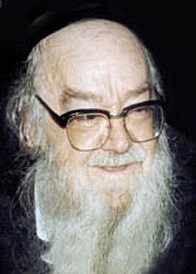

However, when she entered Rav Shalom’s house, the package she was holding, which was a bottle of wine and some baked goods, slipped from her hands.

The bottle of wine broke into many pieces, and the baked goods scattered in every direction. The young girl was terribly embarrassed and she began to cry.
Rav Shalom immediately understood how she felt and ran over to her, and in a loud voice said, “Gevaldig! This is excellent!
“How amazing! Wine spilled in our house! Chazal teach us in Eiruvin (65a), that any house where wine does not flow like water, does not have a sign of Brachah. How great it is for us that wine spilled in our house! Not only that, it happened on the special day of Purim! How fortunate we are! We’ve never had a Purim this special before!”
This was to the extent Rav Shalom went, in order not to embarrass another person, even if that person is a little girl!

Reprinted from the Parshas Bereishis 5781 email of Torah U’Tefilah as compiled by Rabbi Yehuda Winzelberg.

Rav Chaim’s Advice to
Get Another Haircut

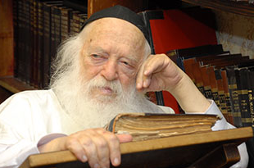

A remarkable story occurred once when a person went to buy an apartment in Bnei Brak. Before signing the contract, he went to visit Rav Chaim Kanievsky, Shlit”a, to receive his Brachah.
When the Rav heard about the apartment, he replied, “Brachah V’Hatzlachah, but first go and get a haircut.”
The questioner was surprised, especially since the week before he had already just gotten a haircut, but he decided to listen to the great leader of the generation without question.
He went to the barber, who was also surprised to see him back a week after giving him a haircut. To his astonishment, he replied that he was about to sign a contract to buy an apartment, and he went to receive the Brachah of Rav Chaim Kanievsky, and the response he received was to go get a haircut.

The barber, who took interest in the details of the apartment, was amazed to hear about the apartment under consideration. The barber told the client, “Stay away from this apartment and run away like it’s on fire!
“I live in the building opposite it, across the street, and there are very serious problems there among the neighbors. Everyone who buys there is in a hurry to sell!”
The man was so thankful to be saved from this bad situation, and he marveled at the wisdom of the Gadol HaDor!

Reprinted from the Parshas Bereishis 5781 email of Torah U’Tefilah as compiled by Rabbi Yehuda Winzelberg.
The Shabbat on the Battlefield That Saved the Soldier’s Life
By Rabbi David Bibi

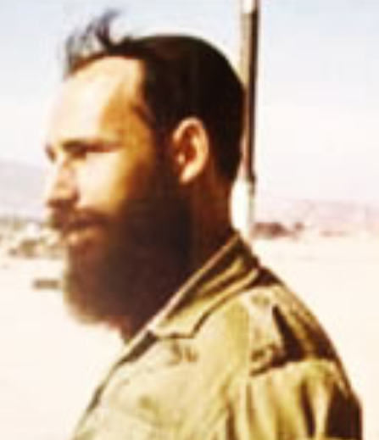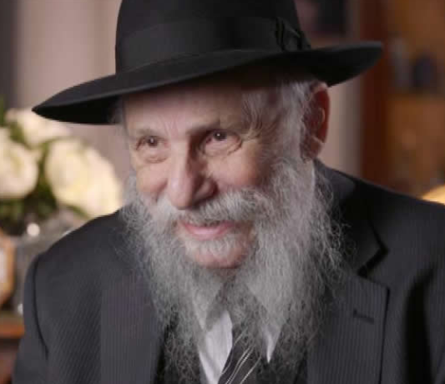
Shmuel Gurewicz as an IDF soldier and later as a prominent Australian rabbi

There are countless stories of people’s lives being saved through observing Shabbat, from Rose Goldstein who was among the minority of those who survived the infamous Triangle Shirtwaist Factory fire on Saturday, March 25, 1911, To the email exchange shared by Dan’s Deals of the man whose decision to refrain from travelling on Shabbat saved him from the Malaysia Air Flight 370 tragedy.
I heard a wonderful story from Rabbi Shmuel Gurewicz, He is the director of The Rabbinical College of Australia and New Zealand and a former member of the IDF. I would like to end off this week’s article by sharing the story with you.

Born in the Soviet Union
Rabbi Shmuel Gurewicz was born in Soviet Russia and escaped with hundreds of others after the war to Paris. In 1949 his family was sent by the then Rebbe to Australia to help establish educational institutions there.
In 1960 he married an Israeli girl and in 1964, made Aliya and along with everyone else was conscripted to the Israeli army in 1965 for national training. Two years later he was assigned to the reserves.
In May 1967, when Colonel Nasser, the Egyptian President massed troops in Sinai on the Israeli border and closed the Straits of Tiran to Israeli shipping, Israel regarded this as a declaration of war. While the diplomats were running around between Washington, London, Paris and Tel Aviv, the Israeli public was preparing for war and expected the worst. The Arab leaders were inciting their populations with dramatic promises that they will “push the Jews into the sea.”

Israeli Army Starts General Mobilization
In Israel the army started a general mobilization. First the pilots were called up and the armored corps. Then more and more reserves were called up. More and more homes were left without their fathers/husbands. People were really frightened and very concerned for the future. Israel was outnumbered one hundred to one. The Egyptians had German scientists developing missiles and the Russians supplying them with tanks, combat jet planes. The French who supplied Israel with the Mirage fighter planes, declared an embargo on the supplies to Israel with the excuse of not supplying arms to a combat zone.
The Chevra Kadisha (burial society) of Tel Aviv alone dug fifteen thousand graves to be ready for civilian casualties.
The Rabbi was called up on the 25th May to report for duty on Friday, the 26th. On Sunday they were moved to a hill, 150 meters from a Jordanian village called Budrus. On the following Friday, their officer Victor came and announced that 10% of the soldiers can go home for Shabbat for a 24-hour leave.

First Group Included Fathers of Three or More Children
He writes: “We were 130 soldiers and the first to go on that leave were meant to be fathers of three children and above. And I fell into this category. Unfortunately, the truck which came to take us back to civilization came at 7.00pm, twenty-five minutes before candle lighting time for Shabbat. So, I could not go as I would have to break Shabbat by travelling. The following day, Saturday, again another thirteen soldiers could go home and I was hoping that this time I would be able to go. But again, the truck came at 7.00pm when it was still Shabbat. Once again, I missed out.
“Victor, my commanding officer, who was not a religious man, took pity on me and said that since I missed out on my leave because of my religious principles, he would let me go on Sunday night for 48 hours. To me this was like an eternity! I was waiting for the day to pass impatiently.
On Sunday afternoon we heard on the radio that Iraq sent two armored divisions into Jordan to bolster their army for the forthcoming war with Israel. A little later, Victor came to announce that all leave is canceled. Since we were in the center line having to defend Israel from Jordan, therefore the readiness level had to be put up onto the highest level. I was terribly disappointed, not so much because of the prospect of the war but because my leave of 48 hours (to see my wife and children) was now canceled!
On Monday (5th June) morning at 5.00am, I went to Victor’s tent and begged him to let me go and see my family even if for a short period of time. Victor then told me that he will let me go but only for eight hours. I must be back by 3.00pm. It must be pointed out that no one knew that the war was to begin in about two hours. Even Victor who was our commanding officer did not know. I did not wait to argue about the eight hours. I took my rifle, my Talit and Tefilin in my backpack and ran!

Wonderful Reunion with Wife and Children
Very soon I got a lift with a motorcyclist and arrived in Jerusalem, at about 8.30am. One can imagine the reunion with my wife and children! After a while the radio reported that heavy fighting has broken out in the south and we were at war.
In Jerusalem, people felt safe. No one believed that Jordan would start any hostilities. Jerusalem was then a divided city. The distance from East Jerusalem under Jordanian control was the same as from West Jerusalem under Israeli control. But at about 11.00, the Jordanians started shelling West Jerusalem. We all went down to the air raid shelter. I ended up again the only soldier with a whole shelter full of women and children.
A little later I called up the city commander and was told to return to my unit. Making my way to the main road, I got a ride with a police car which dropped me off in Ramle. From there I had to walk about 2 hours to join my unit on that hill near Budrus. All the way, shells were exploding in the distance and also nearby.

Couldn’t Find His Fox Hole
I got to my unit at about 5.00pm. I tried to find my fox hole to take cover but could not find it. Something changed there since I left that morning. I found Victor and reported that I returned. He looked at his watch and sternly told me off for being 2 hours late. I began excusing myself that I got stuck in Jerusalem and so on….
He then turned to me with a smiling face and with tears in his eyes: “now I know that there is a G-d in heaven! At exactly 3.00pm, a shell fell and exploded in your fox hole!”
He realized that had I taken leave on the previous Friday night; I would not have been away on that Monday! And I would have not been here telling this story. Shabbat saved my life!
More than we honor the Shabbat, the Shabbat honors us,

Reprinted from the Parshat Bereshit 5781 email of Shabbat Shalom from Cyberspace as compiled by Rabbi David Bibi.
It Depends on the Question

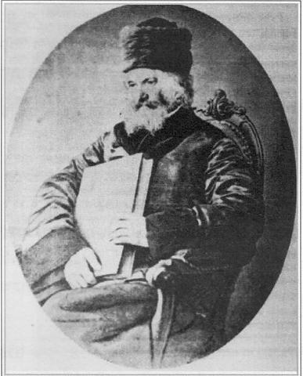

A man came to Rabbi Yehuda Assad for advice. "Rabbi," he said, "I want to buy a certain run-down store, which will give me the opportunity to support my family and myself comfortably. What do you suggest?" Rabbi Assad told him not to buy the store.
The next day, another man came to ask Rabbi Assad for advice. "Rabbi," he said, "If I buy this store, I will, with the help of Hashem, be able to fix it up and earn a decent living."
This time, Rabbi Assad urged the man to go ahead.
When the first man heard the Rabbi's advice to the second, he grew furious and ran to him. "Rabbi, yesterday I asked you about buying the same store, and you told me not to. Why did you tell the other man to buy it?"
"It's very simple," said Rabbi Assad. "You wanted to take on the task of running a run-down store all by yourself, and I felt that it was too much for one person.
“The other man, on the other hand, stated, 'with the help of Hashem.' With a partner like that, I felt he has an excellent chance of making a go of it." (Words of Wisdom, Words of Wit)

Reprinted from the Parashat Bereshit 5781 email of the Jersey Shore Torah Bulletin.
Never Taking Siyata D’Shmaya for Granted

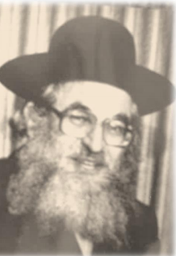
Rabbi Shimshon Pinkus

My Rebbe told me that he and a group of yungerleit would get together every so often. Every time, they would each take on something new that they would daven for to be מצליח (successful) in.
At one get together Dovid Katz* took upon himself that before he walks to yeshiva in the morning, he would daven that he should be מצליח and get to yeshiva safely. After about two weeks, Dovid felt foolish saying a תפילה (prayer) for a simple walk to yeshiva, so that day he didn’t say the תפילה .As he walked through the narrow streets of שערים מאה (Meah Shearim) he suddenly slipped and fell flat on his back!
The day before had been a rainy day, and some posters had fallen off the billboard and now were laying on the wet floor and served as a catapult for Dovid’s fall. Now we are about to begin the new winter zman and it is so important to remember that without constant דשמיא סייעתא (Divine assistance) ,we will have nothing at all.
Rav Shimshon Pinkus ל''זצוק used to say that when we start a new לימוד (learning session) or job, what happens? Of course we daven and plead before Hashem that everything should work out well. The עולם של רבונו (the Master of the World) answers our תפילות (prayers) and things turn out well Boruch Hashem.
Yet many of us will see, continued Rav Pinkus, that as time passes on, we forget to continue davening that everything should continue to go well. It is precisely when the davening peters out – that is when things start to get rough. This is life.
Rav Pinkus concluded: "However, now that we know the secret to the reason for these downfalls, they can be avoided by never stopping to daven for continuous דשמיא סייעתא in everything we are doing, then Hashem has no reason to remove it from us.
There was a story with a fellow who told me that since the beginning of the virus days he was davening very shtark that the virus shouldn't have any effect on him. However, as the months went by he took it for granted that he was perfectly healthy through thick and thin and he did not put too much effort into the davening as he did in the first months of the virus, and lo and behold sooner than later he got the virus.
We learn from this story never to stop davening. And even if a person thinks to himself that he is bored of davening for the same things and he feels that he is not doing anything with his Tefillos (prayers) and bakashos (requests). It's sheker (not true), since every single Tefillah and bakasha to Hashem throughout the entire day and night is pure dynamite and is doing major zachen (merits) in all the oilumos (spiritual worlds). Plus, at the same time he is becoming closer to Hashem and gaining a closer kesher (connection) to the Rebonoi Shel Oilum , which is the reason why we came into this world for.

Reprinted from the Parshas Bereishis 5781 email of Eitz Hachayim.

